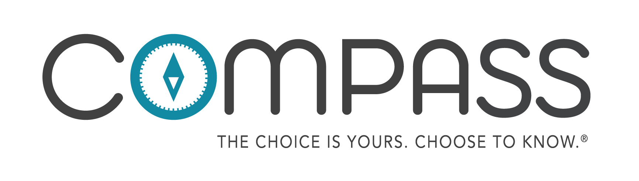
8th Grade Citation Guide:
1. "CDC Fact Sheet: Information for Teens and Young Adults: Staying Healthy and Preventing STDs." Centers for Disease Control and Prevention. Centers for Disease Control and Prevention, 17 Nov. 2015. Web. 7 August 2018. <http://www.cdc.gov/std/life-stages-populations/STDFact-Teens.htm>.
2. Durani, Yamini, MD. "Female Reproductive System." KidsHealth.org. Mar. 2013. Web. 7 August 2018. <http://kidshealth.org/en/teens/female-repro.html#>.
3. "National & State Data." The National Campaign to Prevent Teen and Unplanned Pregnancy. N.p., n.d. Web. 7 August 2018. <http://thenationalcampaign.org/data/landing>.
4. “11 Facts About Teen Pregnancy.” DoSomething.org. N.p., n.d. Web. 7 August 2018. <https://www.dosomething.org/us/facts/11-facts-about-teen-pregnancy>.
5. “Teen Pregnancy.” The National Campaign to Prevent Teen and Unplanned Pregnancy. N.p., n.d. Web. 8 August 2018. <https://powertodecide.org/what-we-do/information/why-it-matters>.
6. "Contraception." Centers for Disease Control and Prevention. Centers for Disease Control and Prevention, 25 May 2016. Web. 8 August 2018. <http://www.cdc.gov/reproductivehealth/UnintendedPregnancy/Contraception.htm>.
7. "Condom Fact Sheet In Brief." Centers for Disease Control and Prevention. Centers for Disease Control and Prevention, 25 Mar. 2013. Web. 8 August 2018. <http://www.cdc.gov/condomeffectiveness/brief.html>.
8. “Condom use errors and problems: a global view.” Sexual Health Journal. CSIRO Publishing. 17 Feb 2012. Web. 8 August 2018. <http://www.publish.csiro.au/view/journals/dsp_journal_fulltext. cfm?nid=164&f= SH11095>.
9. "Reported STDs in the United States." Centers for Disease Control and Prevention. CDC. 1 Jan. 2014. Web. 8 August 2018. <http://www.cdc.gov/nchhstp/newsroom/docs/STD-Trends-508.pdf>.
10. "STD vs STI - What's the Difference? - The STD Project." The STD Project. N.p., 03 May 2012. Web. 8 August 2018. <http://www.thestdproject.com/std-vs-sti-whats-the-difference/>.
11. "STD List - Different Types of Bacterial STDs - The STD Project." The STD Project. N.p., 11 July 2012. Web. 8 August 2018. <http://www.thestdproject.com/different-types-bacterial-stds/>.
12. “Statistics.” American Sexual Health Association. 2018. Web. 8 August 2018. <http://www.ashasexualhealth.org/stdsstis/statistics/>.
13. “Chlamydia - CDC Fact Sheet." Centers for Disease Control and Prevention. Centers for Disease Control and Prevention, 19 May 2016. Web. 8 August 2018. <http://www.cdc.gov/std/Chlamydia/STDFact-Chlamydia.htm>.
14. "Gonorrhea - CDC Fact Sheet." Centers for Disease Control and Prevention. Centers for Disease Control and Prevention, 19 May 2016. Web. 8 August 2018. <http://www.cdc.gov/std/gonorrhea/stdfact-gonorrhea.htm>.
15. "Trichomoniasis - CDC Fact Sheet." Centers for Disease Control and Prevention. Centers for Disease Control and Prevention, 20 May 2016. Web. 8 August 2018. <http://www.cdc.gov/std/trichomonas/stdfact-trichomoniasis.htm>.
16. "Syphilis - CDC Fact Sheet." Centers for Disease Control and Prevention. Centers for Disease Control and Prevention, 20 May 2016. Web. 8 August 2018. <http://www.cdc.gov/std/syphilis/STDFact-Syphilis.htm>.
17. "Genital Herpes - CDC Fact Sheet." Centers for Disease Control and Prevention. Centers for Disease Control and Prevention, 19 May 2016. Web. 8 August 2018. <http://www.cdc.gov/std/Herpes/STDFact-Herpes.htm>.
18. "What Is Viral Hepatitis?" Centers for Disease Control and Prevention. Centers for Disease Control and Prevention, 26 May 2016. Web. 8 August 2018. <http://www.cdc.gov/hepatitis/abc/index.htm>.
19. "Genital HPV Infection - Fact Sheet." Centers for Disease Control and Prevention. Centers for Disease Control and Prevention, 19 May 2016. Web. 8 August 2018 6. <http://www.cdc.gov/STD/HPV/STDFact-HPV.htm>.
20. "HIV Basics." Centers for Disease Control and Prevention. Centers for Disease Control and Prevention, 03 May 2016. Web. 8 August 2018. <http://www.cdc.gov/hiv/basics/index.html>.
21. “Stats.” N.p., n.d. Web. 8 August 2018. <http://www.xxxchurch.com/stats>.
22. "Child Maltreatment." World Health Organization. N.p., Dec. 2014. Web. 8 August 2018. <http://www.who.int/mediacentre/factsheets/fs150/en/>.
23. “National Sex Offender Website." Facts and Statistics. N.p., n.d. Web. 8 August 2018. <https://www.nsopw.gov/en-US/Education/FactsStatistics>.
24. “Did You Know." Safely Ever After. Safely Ever After Inc. N.p., n.d. Web. 8 August 2018. <http://safelyeverafter. com/didyouknow.html>.
25. “Human Trafficking.” Human Trafficking Hotline. N.p., n.d. Web. 9 August 2018. <https://humantraffickinghotline.org/type-trafficking/human-trafficking>.
26. “11 Facts about Human Trafficking.” DoSomething.org. N.p., n.d. Web. 7 August 2018. <https://www.dosomething.org/facts/11-facts-about-human-trafficking>.
27. “Runaway Statistics.” National Runaway Safeline. N.p., n.d. Web. 8 August 2018. < https://arkofhopeforchildren.org/child-trafficking/child-trafficking-statistics>.
28. “Sexual Offender Tactics and Grooming.” Laurel House. North and North-West Tasmania Sexual Assault Support Service. N.d. Web. 7 August 2018<http://laurelhouse.org.au/?page_id=36>.

