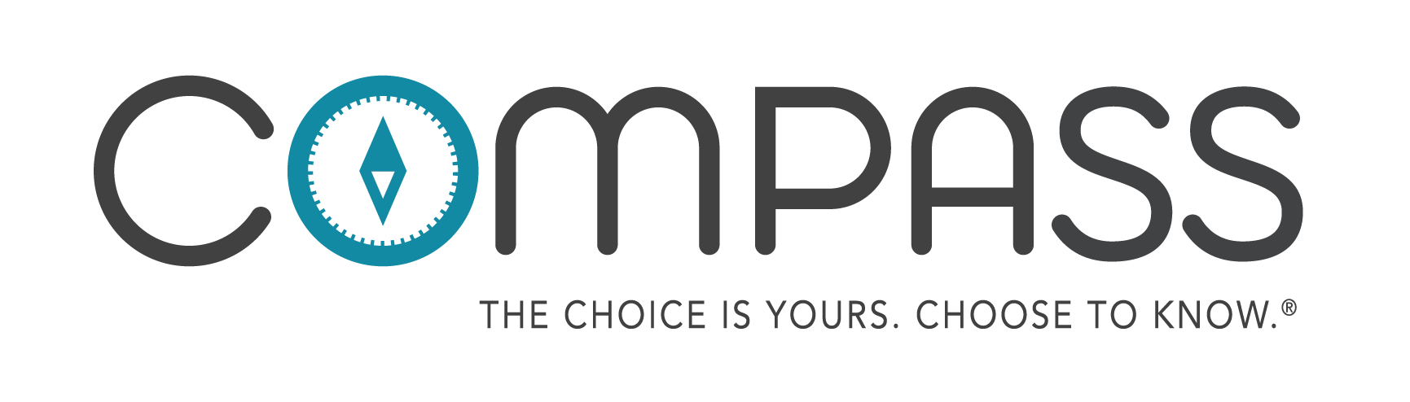
8th Grade Student Workbook Citation Guide:
1. "CDC Fact Sheet: Information for Teens and Young Adults: Staying Healthy and Preventing STDs." Centers for Disease Control and Prevention. Centers for Disease Control and Prevention, 17 Nov. 2015. Web. 30 June 2016. <http://www.cdc.gov/std/life-stages-populations/STDFact-Teens.htm>.
2-3. "National & State Data." The National Campaign to Prevent Teen and Unplanned Pregnancy. N.p., n.d. Web. 30 June 2016. <http://thenationalcampaign.org/data/landing>.
4. “11 Facts About Teen Pregnancy.” DoSomething.org. N.p., n.d. Web. 30 June 2016. <https://www.dosomething.org/facts/11-facts-about-teen-pregnancy.>
5. “Back to School – Don’t Forget Teen Pregnancy Prevention.” The National Campaign to Prevent Teen and Unplanned Pregnancy. N.p., n.d. b. Web. 30 June 2015 < http://thenationalcampaign.org/blog/back-school-dont-forget-teen-pregnancy-prevention>.
5.-6. “11 Facts about Teen Pregnancy.” DoSomething.org. N.p., n.d. Web. 30 June 2016. <https://www.dosomething.org/facts/11-facts-about-teen-pregnancy>.
7. "Contraception." Centers for Disease Control and Prevention. Centers for Disease Control and Prevention, 25 May 2016. Web. 30 June 2016. <http://www.cdc.gov/reproductivehealth/UnintendedPregnancy/Contraception.htm>.
8. "Condom Fact Sheet In Brief." Centers for Disease Control and Prevention. Centers for Disease Control and Prevention, 25 Mar. 2013. Web. 30 June 2016. <http://www.cdc.gov/condomeffectiveness/brief.html>.
9. “Condom use errors and problems: a global view.” Sexual Health Journal. CSIRO Publishing. 17 Feb 2012. Web. 30 June 2016. http://www.publish.csiro.au/view/journals/dsp_journal_fulltext. cfm?nid=164&f= SH11095
10. "National & State Data." The National Campaign to Prevent Teen and Unplanned Pregnancy. N.p., n.d. Web. 30 June 2016. <http://thenationalcampaign.org/data/landing>.
11. "Reported STDs in the United States." Centers for Disease Control and Prevention. CDC. 1 Jan. 2014. Web. 30 June 2016. <http://www.cdc.gov/nchhstp/newsroom/docs/STD-Trends-508.pdf>.
12. "STD vs STI - What's the Difference? - The STD Project." The STD Project. N.p., 03 May 2012. Web. 30 June 2016. <http://www.thestdproject.com/std-vs-sti-whats-the-difference/>.
13-15. "STD List - Different Types of Bacterial STDs - The STD Project." The STD Project. N.p., 11 July 2012. Web. 30 June 2016. <http://www.thestdproject.com/different-types-bacterial-stds/>.
16-17. "Reported STDs in the United States." CDC, 1 Jan. 2014. Web. 30 June 2016. <http://www.cdc.gov/nchhstp/newsroom/docs/STD-Trends-508.pdf>.
18. Chlamydia - CDC Fact Sheet." Centers for Disease Control and Prevention. Centers for Disease Control and Prevention, 19 May 2016. Web. 23 June 2016. <http://www.cdc.gov/std/Chlamydia/STDFact-Chlamydia.htm>.
19. "Gonorrhea - CDC Fact Sheet." Centers for Disease Control and Prevention. Centers for Disease Control and Prevention, 19 May 2016. Web. 23 June 2016. <http://www.cdc.gov/std/gonorrhea/stdfact-gonorrhea.htm>.
20. "Trichomoniasis - CDC Fact Sheet." Centers for Disease Control and Prevention. Centers for Disease Control and Prevention, 20 May 2016. Web. 23 June 2016. <http://www.cdc.gov/std/trichomonas/stdfact-trichomoniasis.htm>.
21. "Syphilis - CDC Fact Sheet." Centers for Disease Control and Prevention. Centers for Disease Control and Prevention, 20 May 2016. Web. 23 June 2016. <http://www.cdc.gov/std/syphilis/STDFact-Syphilis.htm>.
22. "Genital Herpes - CDC Fact Sheet." Centers for Disease Control and Prevention. Centers for Disease Control and Prevention, 19 May 2016. Web. 23 June 2016. <http://www.cdc.gov/std/Herpes/STDFact-Herpes.htm>.
23. "What Is Viral Hepatitis?" Centers for Disease Control and Prevention. Centers for Disease Control and Prevention, 26 May 2016. Web. 23 June 2016. <http://www.cdc.gov/hepatitis/abc/index.htm>.
24. "Genital HPV Infection - Fact Sheet." Centers for Disease Control and Prevention. Centers for Disease Control and Prevention, 19 May 2016. Web. 23 June 2016. <http://www.cdc.gov/STD/HPV/STDFact-HPV.htm>.
25. "HIV Basics." Centers for Disease Control and Prevention. Centers for Disease Control and Prevention, 03 May 2016. Web. 23 June 2016. <http://www.cdc.gov/hiv/basics/index.html>.
26-30. “Stats.” N.p., n.d. Web. June 30, 2016. <http://www.xxxchurch.com/stats>.
31. "Child Maltreatment." World Health Organization. N.p., Dec. 2014. Web. 30 June 2016. <http://www.who.int/mediacentre/factsheets/fs150/en/>.
32-33. “Did You Know." Safely Ever After. Safely Ever After Inc. N.p., n.d. Web. 30 June 2016. <http://safelyeverafter. com/didyouknow.html>.
34. "What Is Human Trafficking." Saving Innocence. Saving Innocence. Web. 30 June 2016. <https://www.savinginnocence.org/about. /the-problem/>.
35. “11 Facts about Human Trafficking.” DoSomething.org. N.p., n.d. Web. 30 June 2016. <https://www.dosomething.org/facts/11-facts-about-human-trafficking>
36. “Commercially Sexually Exploited Children.” Seattle.gov. N.p., n.d. Web. 8 Aug 2015. <http://www.seattle.gov/humanservices/domesticviolence/prostitutedyouth/nationalperspective.htm>
37. “Sexual Offender Tactics and Grooming.” Laurel House. North and North-West Tasmania Sexual Assault Support Service. N.d. Web. 30 June 2016 <http://laurelhouse.org.au/?page_id=36>

